***Volumetric Fog X***

The documentation is divided into two parts :

1. How to use VolumetricFogX.
2. Feature description.
3. ***How to use VolumetricFogX:***

Use of VolumetricFogX is very simple. Steps are as follows:

* Import the VolumetricFogX package in the unity project.
* Importing the package will create a folder VolumetricFogX in asset folder which further contain four folders.

1. Editor
2. Documentation
3. ExampleScenes
4. Resources
5. Scripts

* In Scripts folder, there is a script VolumetricFogX.cs. Apply this script to the main camera of the scene. Now VolumetricFogX is ready to use.
* ExampleScenes folder have some example scenes which can be used for understanding the features and usablity. In the final game we can remove the ExampleScenes folder from the scene.

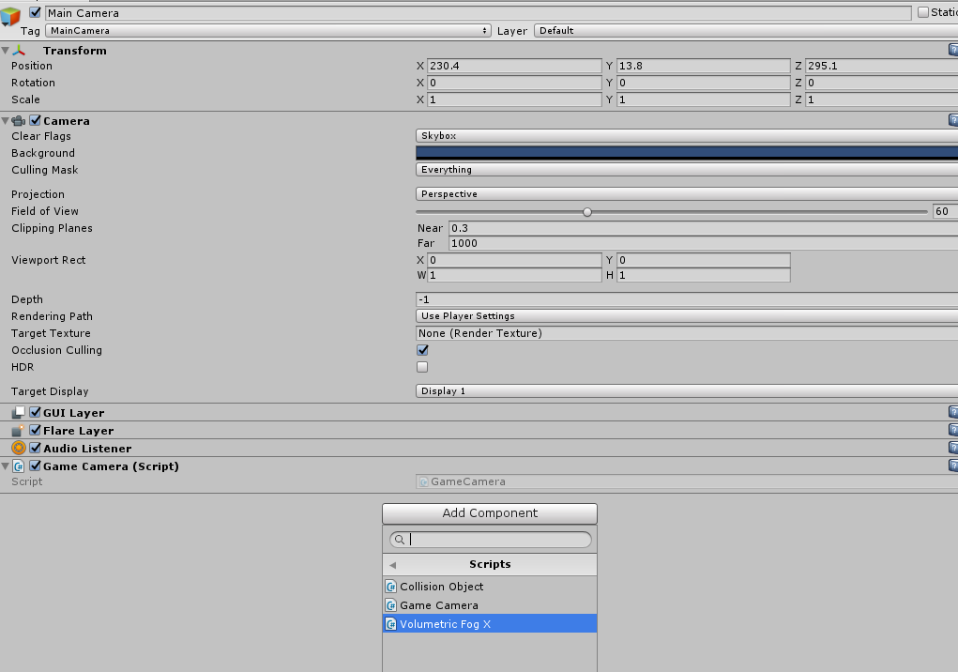

1. ***Feature Description:***

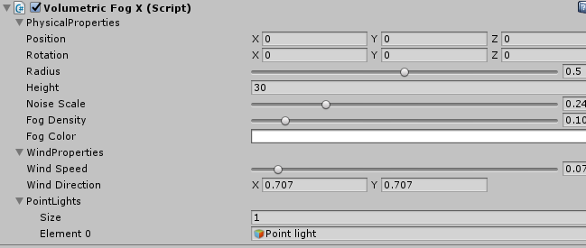

Features have three segments :

1. **Physical Properties** :
   1. **Position** : This is the central position of fog area where we want to apply fog. This is a public variable which can be set from outside. If we change this position with camera, it will seem that volumetric fog is infinite or which never ends since it is moving with camera and will never end.
   2. **Rotation** : This is the rotation of the volumetric area. It is public variable which can be used from outside.
   3. Radius : This is slider which takes values from 0 to 1 and represent radius of the volumetric fog area. 0 stands for 0 radius means no fog area and 1 stands for camera far clip distance. It is public variable which can be used from outside.
   4. **Height** : This is the height of the volumetric fog area.
   5. **Noise Scale** : This is the slider which takes values from 0 to 1 and represent the scale of the noise present in the fog area.
   6. **Fog Density** : This represents the density of the volumetric fog. 0 density means , there is no fog in the scene.
   7. **Fog Color** : This is the color of fog which is public variable so can be set from outside.
2. **Wind Properties** :
   1. **Wind Speed** : This is slider 0 to 1 which represents the wind speed in the fog area. 0 means no wind speed. 1 means maximum wind speed.
   2. **Wind Direction** : This 2d vector which represent a direction in x-z plane along which wind is blowing.
3. **Points Lights** :

Volumetric Fog supports point lights. Create any point light, set its properties and drag it on PointLights. There are maximum of 6 point lights which are supported in this version.